D279 - Task 1

# PART - 1

### A1

### Website Functionality

The new Paradigm Pet Professionals will be about making it more user-friendly, addressed not only to the target audience but also to the company's shareholders. The website is designed with the possibility of being adjusted to any screen size. Therefore, the website will support even desktops, tablets, and mobile phones. This is a static but still fully functional piece of the image  
That away, it's the dynamic contact form that makes the contact page smart and easy. A lot of the collectors were able to easily find information there too. If you also visited the website you know that before the release of the product I was sure to specify the message too.  
To simplify the booking process, the location will include very intuitive forms for both contacting a vet and subscribing to the newsletter. You will find live CTAs plus a lot of redirects for the different features of the website (e.g., schedule a consultation, explore pet care resources, or get expert advice).  
GetSocialedIn content on pets has high chances to engage users through their easily shareable pet care articles. People can easily share the pet care advice of this site to their circles on many social media platforms by pressing some like or share buttons.  
The breadcrumb navigation system will guide users to their current position and location within the site improving the site's user-friendliness. Besides the FAQ section, there will also be a component which is a click and reveal one. It allows users to only click the topic in which they are interested and then the answer appears without the need to load the whole page giving a sleek and well-organized effect.

### Micro Interactions

For greater user interaction, the web page will include many micro-interactions to facilitate or ease the usability. Tapping by Mobile users will display additional content and interactive features by holding down. A horizontal scrollbar will allow the user to scroll through pet articles and resources effortlessly without the issue of endless scrolling. A progress indicator bar will appear for showing the status of a user by marking them as successful in completing the form or by the consultation process.  
Additionally, the website will be contextually audio and visually qualified to inform the proper submission of forms, thus elevating user confidence. Interaction through a mouse click and hover that occurs when users are prompted with the appearance of text or image to get acquainted with the content. In the case of section changes, seamless page transitions will let the users experience a smooth browsing journey by maintaining the same transformation as they move from one part to another. Finally, hover animations on buttons and linked graphics will direct the users to the clickable elements and so, this will both improve the user experience and engagement.

### Meeting Audience Needs

User experiences are being uplifted through the redesign by the smoothing and quickening of them. Positioned on the top of the page a navigation bar that goes horizontally, with a search bar being placed above it. This makes it easier for the users to quickly find the help they need. Real-time suggestions through the search bar allow, the users, to choose accordingly while the process becomes smoother which consequently results in them finding the information they need faster.  
The menu line will have menu tabs that will be highlighted when the cursor is over them, it will give direct feedback as to which ones have the possibility of being selected. The designed pages will contain more content and give detailed information that is not in blocks of text that seem like they are fragmented. Moreover, in-builts links are crafted to channel users to more educational resources, by which users will find it easy to navigate and get more information.  
The design that is planned for the very purpose is to create knowledge about challenging issues like better accessibility by including several menu options such as the expandable FAQ, visual feedback regarding button clicks, and well-organized sign-up and contact forms. The small short animations that appear for the users are expected to draw their attention towards the content and also to provide the users with an easily manageable navigation experience. Generally speaking, these new features will make a more intuitive, enlightening, and interactive structure for users.

### Meeting Stakeholder Needs

To meet the needs of the stakeholders, the platform must include some significant features, among which traffic is the most important tool. For this purpose, we will add sign-up options for business consulting and share buttons to social media so that the users can easily share the site with others. We will intentionally place quite a few call-to-action buttons to make sure the user experience will be seamless and to thereby create their use.  
It is of vital importance to make the site mobile-optimized for the reason that such a technique will help the users propelled through the different platforms where the site is located and thus cause the boost of traffic and shares. As a result of these changes, the visual appearance and functionality of the site will improve, increasing user engagement with the site.  
Also the well-structured content is the basic key and the critical need to focus which will bring fullness to the user experience and motivation to the users to the tabs and pages which are already available. The main aim will be to create a resource that is overall seamless, interactive, and user-friendly, which keeps the stakeholders happy and works with greater reliability.

### A2

### Target audience

The new webpage will be for new, current, and prospective Bird owners who are seeking to get information about their Bird, or are exploring other species of interest. It is created for a broad audience such as those who are 10 and above, giving the guarantee that the content is easy to access and understand. However, on the Paradigm Pet Professionals site, the users do not need to be worried as its content will be articulate and user-friendly to navigate.

### Resources and Care Information

The Bird Finder section will be the main focus of the new page and will guide users in finding the best Bird for their specific requirements by providing them with a list of questions. These questions will be about the most important issues such as whether they would prefer a saltwater or a freshwater Bird, the corresponding size of the Bird they want to have, and the level of the Bird's care. In addition, the page will contain the basic information for each of the Bird species, e.g. which food to give them, what size of Nest they need, and what traits are their most common behavior.  
Moreover, the resources will cover primarily Nest maintenance, health and safety as well as the most important Bird-keeping equipment. Consequently, thanks to the development of these educational materials, Bird owners will increase the probability to learn better while at the same time, people shooting through the website will be more engaged.

### Living Environment

This page is a full-fledged guide designed to lead through the process of setting up an environment for a particular Bird species. If there is no particular advice for your chosen species, there will be an additional link to the common Bird setup resources you can check out. It also contains some recommendations on Nest size, type of air filtering, factory options for beauty, other birds that you can place along with the first bird. Over and above that, you will go through Bird care essentialities, like, for example, the best environment for the Nest, lighting standards, and the food you should feed them.

### Social Needs and Expert Guidance

The website page will have expert research and advice, and users will bring a lot of valuable information to the discussion about their Bird. The page, in addition, will focus on how socializing is a salutary lifestyle habit for a caged Bird. Let's say a user is thinking about a betta Bird for his bird-bowl and he/she needs to know that the betta species are a solitary one and when they live with other bird the opposite is the case, and they may tend to be the one who is attacked. Thus, factors like good compatibility partners, food demand, and reproduction information will be listed for example.  
At least the call-to-action button will set an agenda for users to make an appointment or to chat with us at ease. The coalescence of this kind will improve our site's identity and also users' involvement in it.

### A3

### Audience needs

A part-time intern was responsible for the creation of the first Paradigm Pet Professionals website due to which the website was devoid of interactive content, the details were incomplete and the users had a limited contribution rate.  
To do that, we will properly present the company, its mission, and how it caters to its clients through comprehensive information and a correct list of the things users will be able to access. You will find the revitalized website will open with an introductory summary that explains the company’s goals and the expertise it boasts of, especially the pet consultations that are tailored to different sorts of pets shall have emerged as well.  
New website navigation will have a horizontal menu along with a drop-down category for pet selection. Hence, the users’ access to various sectors on the website can be more precise. The FAQ section is actually very limited at the moment, there are only three questions related to just a few pets, so users have to operate many steps to find the necessary information. Due to the idea of creating an interactive "click to expand" function, users should be capable of putting their cursor over a category they are interested in and different characteristics of specific pets will be available for choosing, thus making the process more user-friendly.  
Moreover, the former site disappoints the vita through a lack of visual appeal and the application of text that is too simple and that does not help users. The new design will give a response to this by bringing in the images and videos of upgraded quality in addition to the links to the related YouTube content. Also, the more elaborate written insights on pet issues will be the main components of the website, hence a more holistic and exciting use will be ensured.

### Meeting Stakeholder Needs

The new website will be a user-friendly navigation system in an alphabetical format, in order to enable visitors to navigate in a better way. In addition, color scheme would be used to make sure that it is not fatiguing the visitors' eyes and at the same time makes it look stylish. The company's logo will be positioned both prominently and in the top, middle, and bottom of every page to strengthen the identity of the brand. Watermarks on text boxes and the usage of licensed images will also contribute the brand representation.  
To optimize the site for search engines, it will integrate the use of various keywords consistently to catch the web crawlers' attention. The way to do this is via short headings and enticing meta descriptions on each page, making the most of content, and including headings and meta descriptions that had been neglected in the older website.  
In addition, the new layout will still come under a structured design, with sections specifically for every one of the pet types, arranged in alphabetical order, which will help the layout look less cluttered and streamline user experience. Call-to-action buttons will be put in the right places to give the user quick, easy prompts and links.  
One of the major issues that the first site had was that the site was not interactive at all. It consisted of only static texts and images. To tackle this, the new design will also include ways for users to share content with social media platforms and other features like video and images, besides content links and interactive mouse effects to engage users.  
Moreover, the old website was ineffective in the promotion of services and lacked of displaying contact information. The new site plan is to put numerous call-to-action buttons on all pages that lead to contact forms and consultations forms. TIncluding a call-to-action form allows clients not only to have all the information that they would have given such as their email address, name, etc. but also to let the users book an appointment. This strategy ensures successful website service promotions, which in return mainly affect easy contact finding and sign-up options.

### A4

### Visual Sitemap

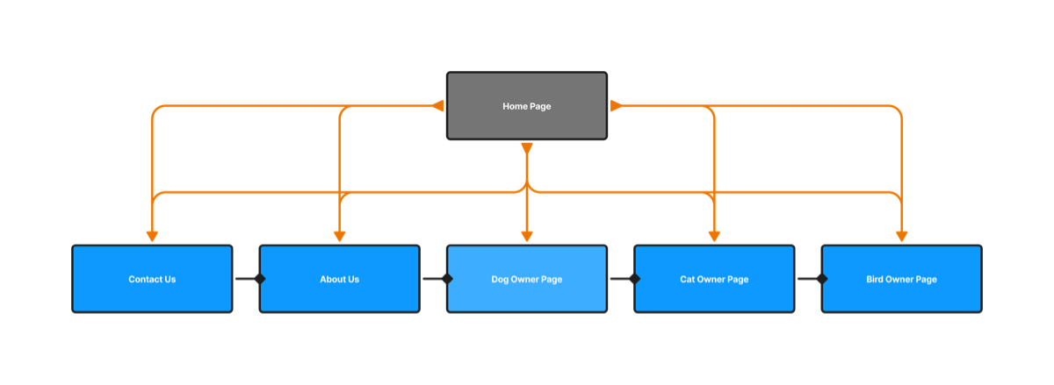

### A5

### Meeting Audience Needs

The website's better structure makes it easier for users to get the information they need. The top horizontal navigation with drop-down menus is clear and well organized and it includes pet categories—such as dogs, cats, and Bird—along with essential services like Contact Us, and Consultation Scheduling. The way a live search box with auto-suggestions is integrated into the system is a big plus as it not only helps users to find out quickly about the info they are interested in but also contributes to the increased visitors' satisfaction.  
Designed to be responsive, the website operates smoothly on all forms of PCs, tablets, and mobile phones, therefore, it is user-friendly to the maximal extent possible. Then, depending on the screen, page content including the images, and text, the usability, and readability also change automatically.  
Each pet category—dogs, cats, and Bird—has its web page that deals with the crucial topics, such as nutrition, health, behavior, grooming, etc. In the interactive FAQs section, users can expand answers based on the specific pet they are researching. The consultation page specifically shows the different options (if possible) for obtaining the advice of the experts while opportune call-to-action buttons are a way to prompt visitors to reach out to a professional or book a session with a counselor.  
Adding to it, the website has a general contact form and a scheduling form for consultations so that the clients are enabled to contact the professionals and ask for help. Thus, with this standardized method, user consultation has direct access to qualified people.

### Meeting Stakeholder Needs

To strengthen the business's services, the new information architecture is put to use by means of the minimum content updates. The website is made in such a way that the mentioned "Dog," "Cat," and "Bird" categories are able to be updated separately; thus, more new content can be inserted without the website stopping to operate. The FAQs part has been designed in a way that it allows the smooth addition of popular questions to the list in the longer term.  
The website becomes search-engine-friendly with the addition of the relevant metadata, useful keywords, and headers. The social media sharing integration application, that is, buttons, allows such a user behavior as sharing resources and articles with friends, hence, the website's audience grows and new people get interested. Not only that, but the site’s mobile and navigation are user-friendly and lead to not scaring away new users and getting the existing ones to come back for more.  
One of the website features is the tracking tools, which control user behaviors-including clicks on consultation forms, stay period on page, and pet content engagement. These reports are used for making strategic improvements for more consultation bookings and help stakeholders in services popularity identification.  
The rebrand, which is the result of both the clean and interactive modern interface and putting the company logo on every page, is not just a brand visibility upgrade it also increases the recognition of the brand. Informational texts with matched call-to-action buttons give clients the feeling that a company is a trusty partner. This impression is completed with social media sharing options and small interactions to the user within the site, which in turn makes a user-oriented excellent experience.

### A6

### Primary Navigational Elements

The main navigational method that the website will utilize will be a horizontal navigation bar that is placed in the top center area of the page. There will be a drop-down menu in this bar that contains links to contact data, company details and pet-related content. When the users click on the "Contact" tab, they will be taken to the scheduling form. The "About Us" tab will be provided by the company, which is a brief description about the company along with a description of the services offered. Also, in the appropriate "Pet" tabs the categorizing of the information for cats, dogs, and birds will be done which will help in the quick and easy navigation for the users.  
To make sure the navigation will be a one-click process, the logo of the company will be visible on all the main pages. If users click on the logo, they will be taken back to the home page. A search bar is going to be placed right above the navigation bar, and it will be available on all website pages. Such a search bar as this allows live suggestions for the users to feel less of a struggle to reach the information they want. In general, the design in view here is intended to provide a smooth and well-organized browsing opportunity, which implies the fast access to the various sections of the site.

### Secondary Navigational Elements

Breadcrumb navigation as a secondary navigational element would be added to the website and utilized as we aim to enhance the user experience. The feature which would be directly placed under the top bar would make it very easy for the user to follow along their current path. i.e. the path could look like this: Home > Contact Us > Scheduling Form. This shows the users how the transition from one page to the other would be simple.  
User interaction would be greatly improved with the introduction of both primary and secondary navigation elements and the calling-to-action buttons within the navigation and search bars. By making the user experience much simpler, we are going to induce curiosity within the user to dig deep into our website, thus creating a strong relationship with our brand.  
We would also set up a data collection method to help our analytics team in finding out about a user's behavior. This will mean probing into the depth of the activity on the page with respect to navigation clicks, visit frequency, user metadata, and the most frequently accessed tabs. Such findings will help to pinpoint the most popular areas of the site and learn more about our target audience's requirements.

### A6

## A. Audience Needs

The navigation bar is the key component that leads users to a way through the side most naturally and simply. Similarly, the live suggestions are aimed at provoking users the right way, finding them particularly useful when they have no idea where to click next. To further improve the site's navigation, the breadcrumb navigation links provide an uncomplicated alternative, thus, a user's current position on the site will be clearly displayed.  
Unchanged site architecture will result in a sense of simplicity and will contribute to the immediate comprehension of how the site functions. One of the things that were revised was a new logo creation in a familiar manner and the addition of a new breadcrumb menu while in most cases the navigation bar tended to be fixed in place providing guidance.  
The same mobile platform will be designed to fit the same principles and a diagonal bar menu will serve as a key of providing the best version. This way of tourance not only restricts the contents but also keeps the interface components available in the hamburger menu.

### Stakeholder Needs

In the navigation bar, vital call-to-action buttons such as "Schedule a Consultation" and "Contact Us" call on visitors to reach out to the business. Using interactive FAQs accompanied by expandable answers, visitors can have the convenience of finding the information needed without going to different pages thus enhancing user engagement. This well-organized, and immediately comprehensible structure provides the likelihood of elongating the time of visits and ensuring visitors' return, which as a result, makes it convenient for them to explore pet care contents.  
One design for the menu on all pages serves as a solution which is a source of clearness and connectedness, and thus, it provides an unproblematic search for the visitors. Besides the navigation system detecting user interactions with menus, CTA buttons, and the search bar, it will also give practical insights into user behavior. The Analysis tools will keep track of the traffic flows to the different pet-related articles, e.g., those which are about dogs, cats, and birds, to deliver insights that the managers can utilize as a guide in determining the contents that they will prioritize.

### B. Wireframe

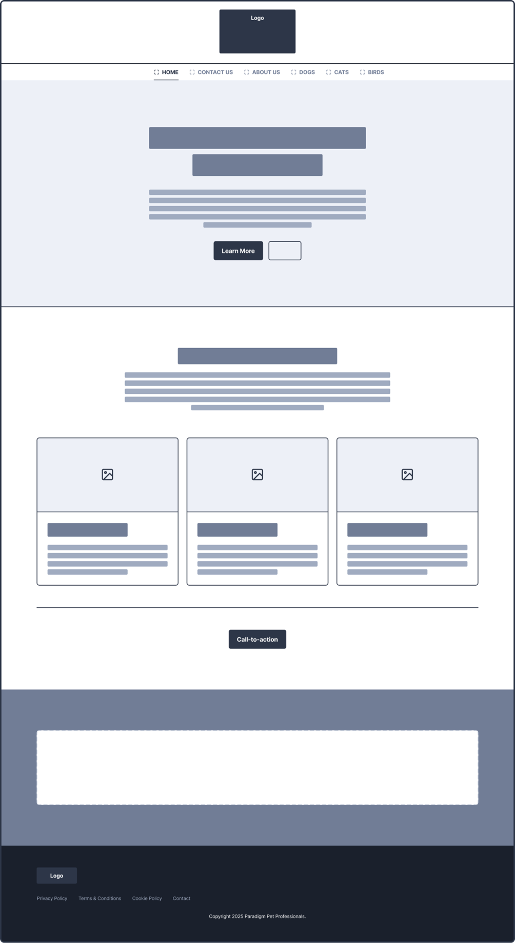

# PART - 2

### C1

### Home Page:

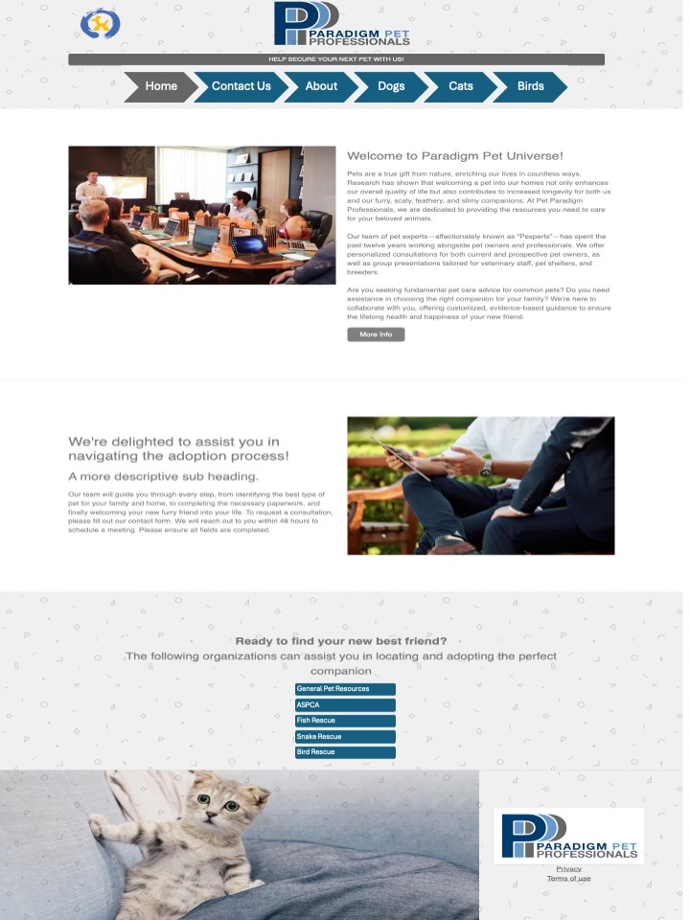

### Cat Owner Page:

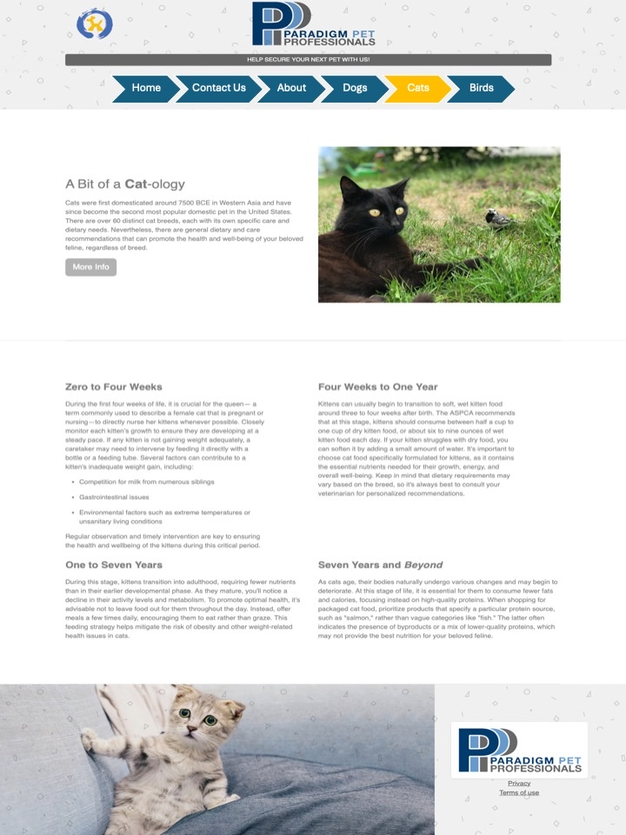

### Dog Owner Page:

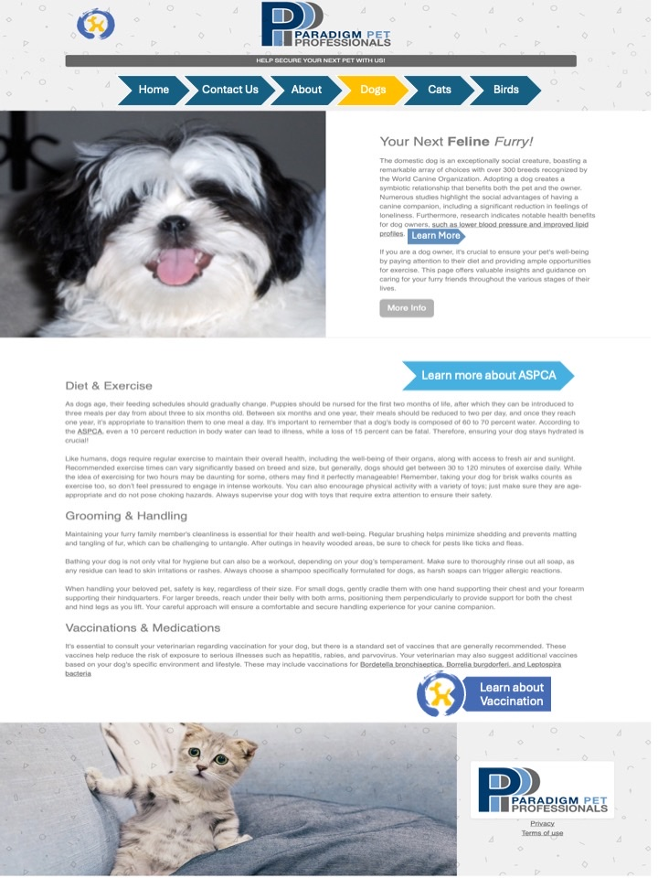

### About Us Page:

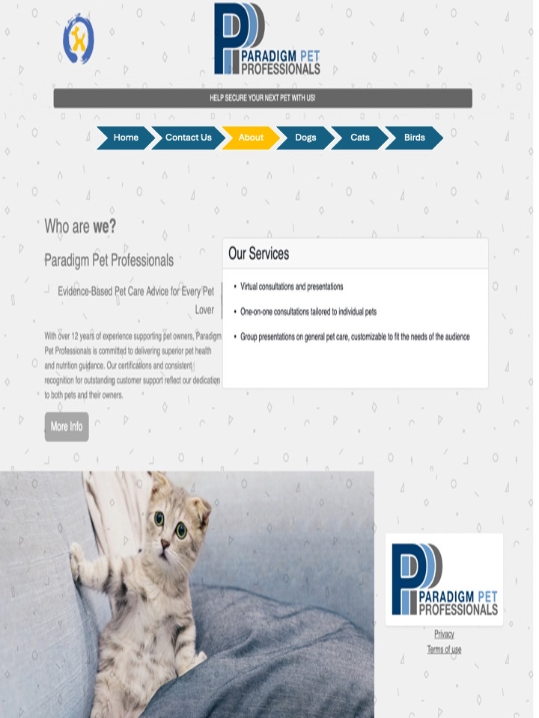

### C2

### Bird Owner Page:

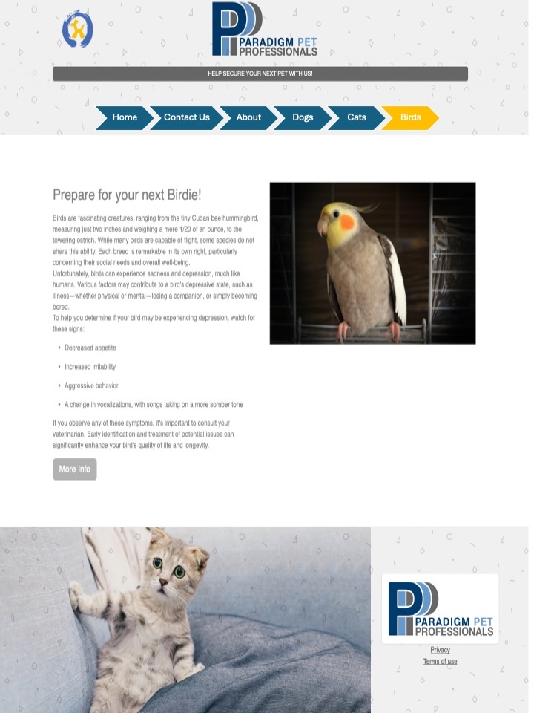

### C3

### Contact Page:

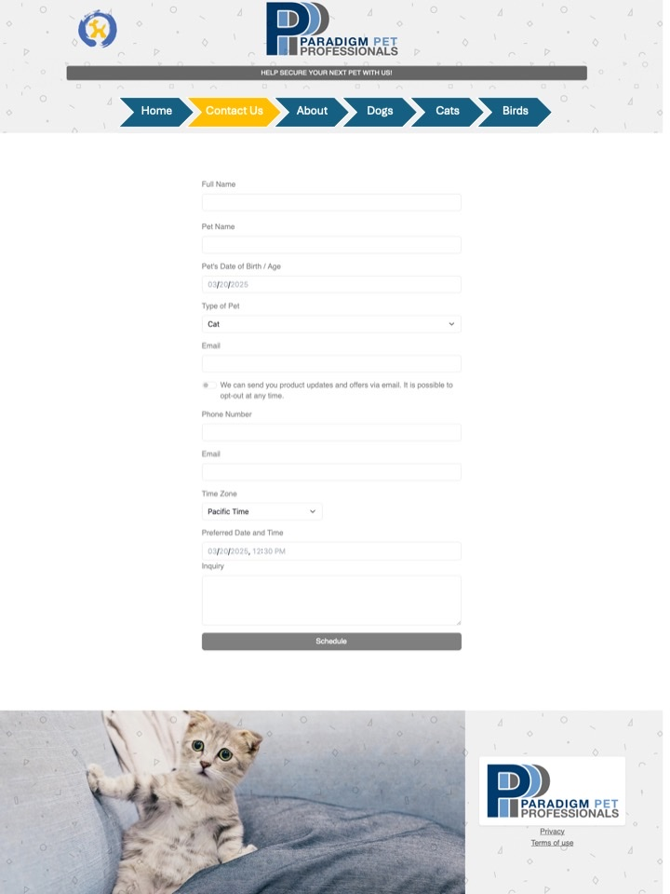

### C4

### Navigation Element:

